Welcome to "Hotel Princess Park" at Devka Beach, Nani Daman. Located merely 150km away from Borivali, Mumbai - Daman is one of the Union Territories of India, you can very easily assess, as it is located near to the Mumbai - Ahmedabad National Highway no.8, via Vapi by road and railway. Daman - a quaint twin-town - in part, still in its Portuguese colonial past is an ideal location at the northern end of the shores of Devka beach surrounded by lush greenery and beautiful Arabian Sea, and has a lots to offer its tourists.
"Hotel Princess Park" has all the facilities and luxury under one roof. The only hotel with unlimited facilities in Daman.

Rooms With a ViewHotel Princess Park
Hotel Princess Park has 43 well- appointed A/C rooms. The accomodation is split between Super Deluxe Rooms, Premium Category; a majority of which are sea-facing. All the rooms at Hotel Princess Park are:
- Beautifully furnished with an ultra modern bathroom having a individual space
- A cable connected television
- Running hot and cold water
- Very economically priced
- Every room with a picturesque view

RecreationHotel Princess Park
We at "Hotel Princess Park" wish to keep our guests of all ages and interest occupied with various activities for the fun lovers as well as for those who are health conscious. This add to the charm of Hotel Princess Park making it an ideal resort for corporate and families.
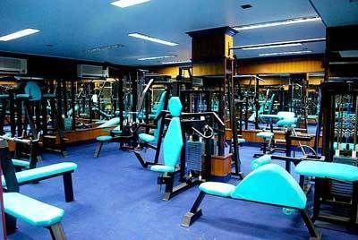

Healthclub
Hotel Princess Park
A state-of-the-art well equipped A/C Gymnasium.

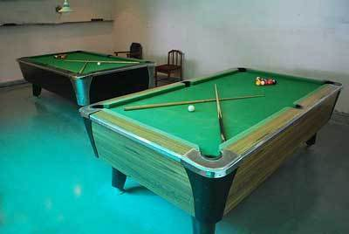

Pool Table room
Hotel Princess Park
We wish to keep our guests of all ages and interest occupied with various activities for the fun lovers.
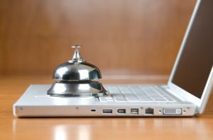

Wifi
Hotel Princess Park
Cyber Cafe' Wifi Chargable at limited area.

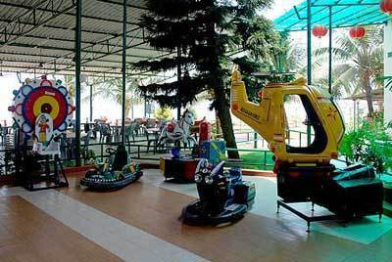

Rides
Hotel Princess Park
We wish to keep our guests of all ages and interest occupied with various activities for the fun lovers.

High TideHotel Princess Park
The beach garden restaurant-cum-bar overlooking the Arabian Sea, is famed in Daman for its excellent cuisine and cellar, both Indian and continental. Our chefs at Hotel Princess Park serve you the best Vegatrian and Non - Vegetarian delicacies in Daman ranging from Indian, Chinese, Punjabi, Gujarati, Rajasthani and Continental cuisines. Enjoy it along with chilled beer in the noon at our A/C Bar or some Whisky, Vodka, Rum in the evening. Our well stocked Bar is the right place for those who want to go high with a large variety of Cocktails, Mocktails and Beverages to offer.

Blue WavesHotel Princess Park
The air conditioned Banquet-cum-conference venue, has an aura of its own. It is well equipped with seating capacity from 50 to 200 delegates making it an ideal location for a variety of corporate programmes. Wheather it is a business cum pleasure meet, workshop for staff or a dealers meet to enhance your sales figures, we, at Hotel Princess Park, Daman make it a meamorable working vacation. The party lawns are recommended for open air conferences and live entertainment programs.

Ocean BedHotel Princess Park
The exclusive conference venue, has all the modern facilities - an appropriate choice for corporate to host an event at Hotel Princess Park, Daman.

WeddingsHotel Princess Park
The Princess lawns provide an ideal outdoor setting for functions like marriages, parties, etc with seating capacity of 100 to 1500 persons. Weddings, receptions, parties and other most important events of one's life, when conducted at "Hotel Princess Park", Daman; stays memorable for ever. With all such facilities our staff and management have taken an oath to provide all its guests with the most efficient and personalized service at round the clock on your back. In other words your request is our command. We have made an attempt to reach you and in return expect you to grace us with a chance to serve you along with your family, friends and your organization.

Rooms
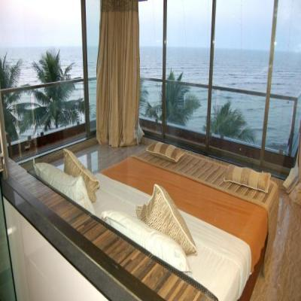
Beach Facing Room
Hotel Princess Park

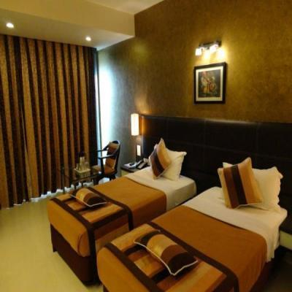

Tariff
The best hotel you can get in daman.

General TariffHotel Princess Park
Premium Delux Room 4,000/-
Premium Suite Room 4,500/-
Princess Premium Room 5,000/-
Princess Delux Room ( 6 Bed ) 6,500/-
Extra Person / Child 400/-
ALL ROOM TARIFF INCLUDES COMPLIMENTARY BUFFET BREAKFAST
- Check in time after 12:00 noon & Check out time 11:00 am [strictly].
- Full payment in advance at the time of booking or check in.
- No Refund on cancellation for what so ever reason.
- Outside food & liquor will not be allowed in hotel. If a guest found doing so he will be charged for the same without any clarification.
- Service tax as per applicable.
- Duration of the stay has to be confirm at the time of booking.
- Complimentary buffet breakfast will be served at our restaurant from 07:30 am to 10:30 am [strictly]
- Guests are requested to take their belonging like mobile, ornaments or cash. The management will not be responsible for any loss of the same.
- Guests are requested to take their key tags along with them whenever they visit the restaurant.
- In case of electricity failure the power will be supplied by generator, but will not be able to operate A/C & gizer.
- In case of any electronic device like A/C, TV, Telephone or Gizer causes any convenience in between the stay. We will try to solve the problem but in case we fail to do so for what so ever reason. We won't be able to shift the room or no policy of paid redemption of the amount.
- During the stay your co-operation regarding the above mentioned will highly obliged.
- Photo ID proof compulsory.

Rooms
Beach Facing Room
Hotel Princess Park

Premium Deluxe Room
Hotel Princess Park

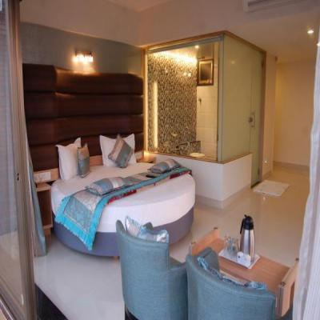
Princess Honeymoon Suite
Hotel Princess Park

 